Computer guesses numbers :
import random
def computer_guess(x):
low = 1
high = x
feedback = ''
while feedback != 'c':
if low != high:
guess = random.randint(low, high)
else:
guess = low
feedback = input(f'is {guess} too high (H), too low (L), or correct (C)?').lower()
if feedback == 'h':
high = guess - 1
elif feedback == 'l':
low = guess + 1
print(f'the computer guessed the number, {guess} correctly')
computer_guess(50)

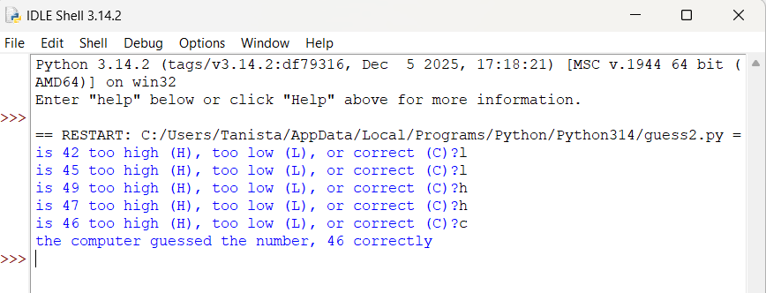

ROCK, PAPERS, SCISSOR Game :
import random

def play():
user = input("Enter your choice: 'r' for rock, 'p' for papers, 's' for scissors\n")
computer = random.choice(['r', 'p', 's'])

if user == computer:
return 'Tie'

if is_win(user, computer):
return 'You Won !!'

return'You lost'

def is_win(player, opponent):
if (player == 'r' and opponent == 's') or \
(player == 's' and opponent == 'p') or \
(player == 'p' and opponent == 'r'):
return True
print(play())
